**EXPERIMENT-4**

**By: Amogh Garg**

**AIM:** Implementation of CE amplifying configuration. Plot gain vs frequency graph.

**SOFTWARE USED:** LT-spice

**THEORY:** Bipolar Junction Transistor (BJT) is a device with three terminals known as emitter, base, and collector. The BJT can be categorized into two types which known as NPN and PNP . For NPN, the emitter and collector of the BJT are made from n-type material while its base is made from p-type material. In contrast, the emitter and the collector of PNP are made from p-type material while its base is made from n-type material. In either type, a common emitter amplifier is configured by passing an input signal to the base terminal while measuring an output signal at the collector terminal. For the purpose of theoretically calculation, we would consider NPN type of BJT. Figure 1 shows an example of NPN type of BJT that configured as a common emitter amplifier. In this configuration, the input signal is voltage input (Vin) while the output signal is voltage output (Vout). The emitter terminal is common to both the input and output voltages and therefore it is known as a common emitter.

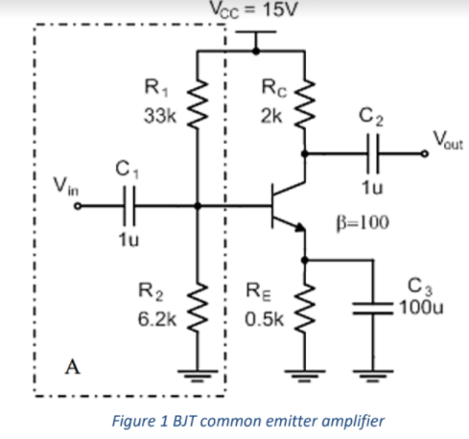

The single stage common emitter amplifier circuit shown in figure 1 uses what is commonly called “Voltage Divider Biasing”. This type of biasing arrangement uses two resistors as a potential divider network across the supply with their centre point supplying the required Base bias voltage to the transistor. Voltage divider biasing is commonly used in the design of bipolar transistor amplifier circuits. This method of biasing the transistor greatly reduces the effects of varying Beta, ( β ) by holding the Base bias at a constant steady voltage level allowing for best stability. In Common Emitter Amplifier circuits, capacitors C2 and C3 are used as Coupling Capacitors to separate the AC signals from the DC biasing voltage. This ensures that the bias condition set up for the circuit to operate correctly is not affected by any additional amplifier stages, as the capacitors will only pass AC signals and block any DC component. The output AC signal is then superimposed on the biasing of the following stages. Also a bypass capacitor, C1 is included in the Emitter leg circuit. This capacitor is effectively an open circuit component for DC biasing conditions, which means that the biasing currents and voltages are not affected by the addition of the capacitor maintaining a good Q-point stability.

**OBSERVATION:** Circuit a) 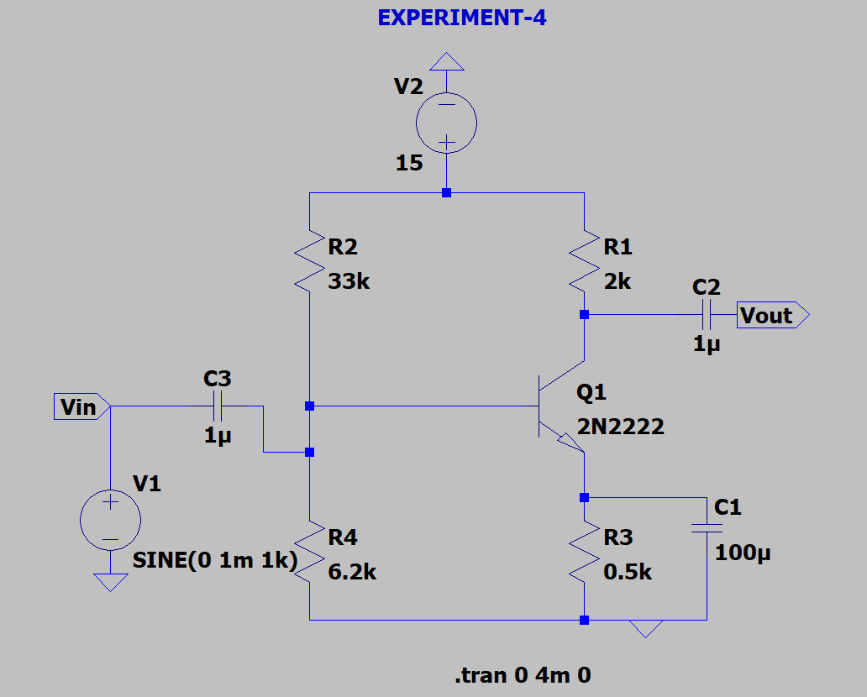

Output a) 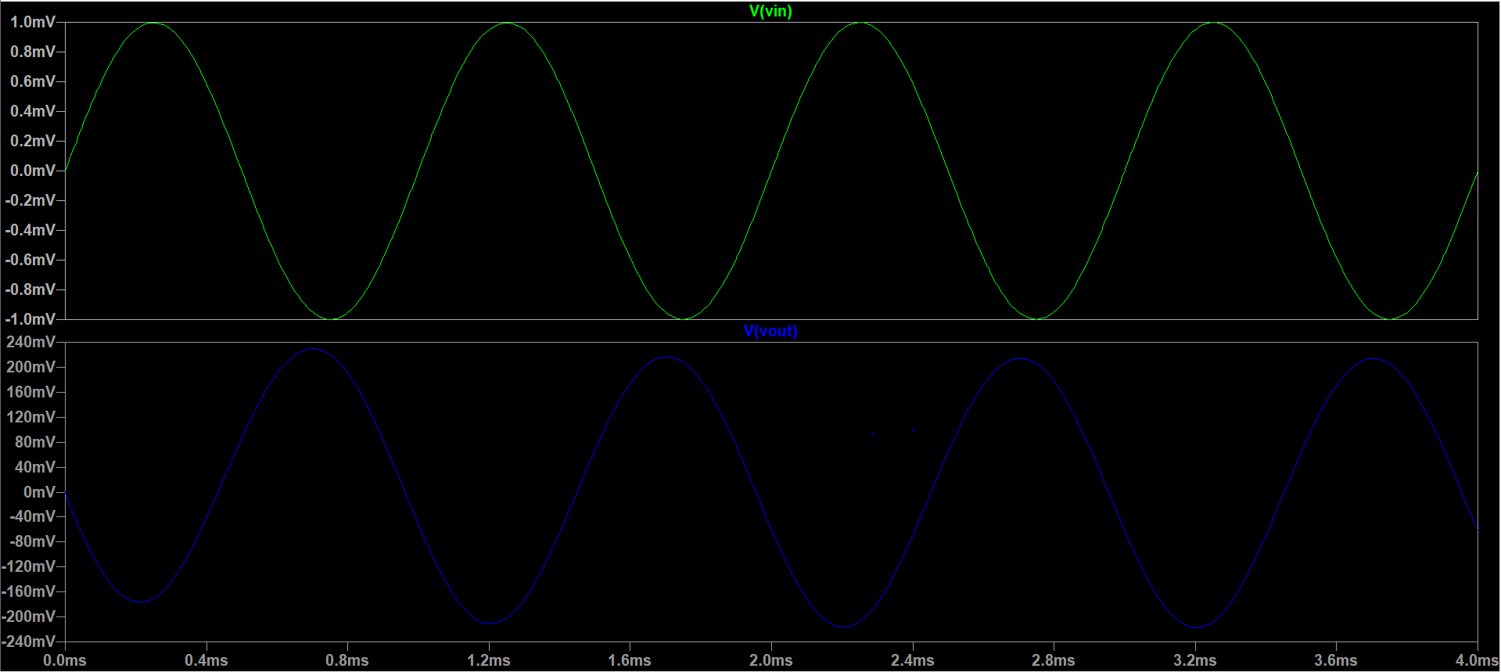

Circuit b) 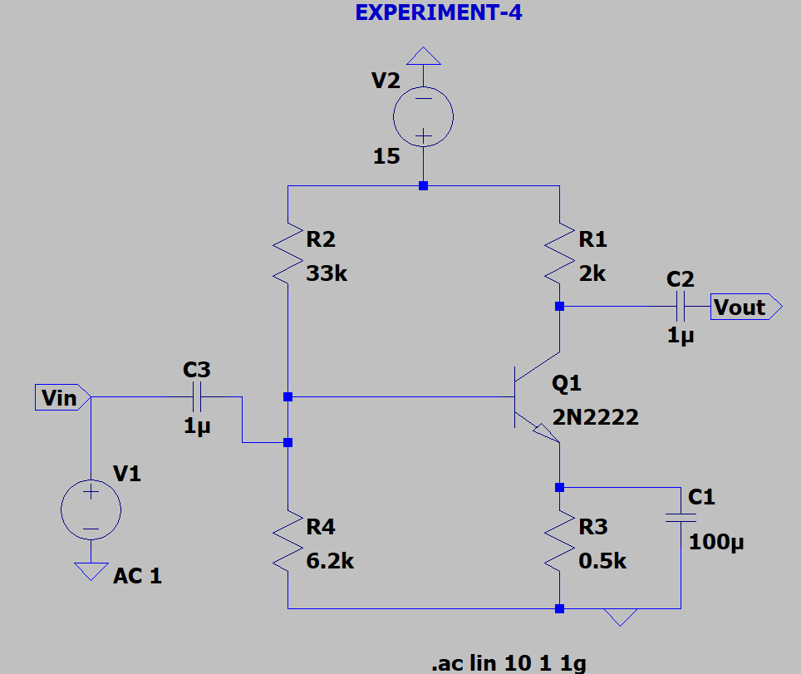

Output b) 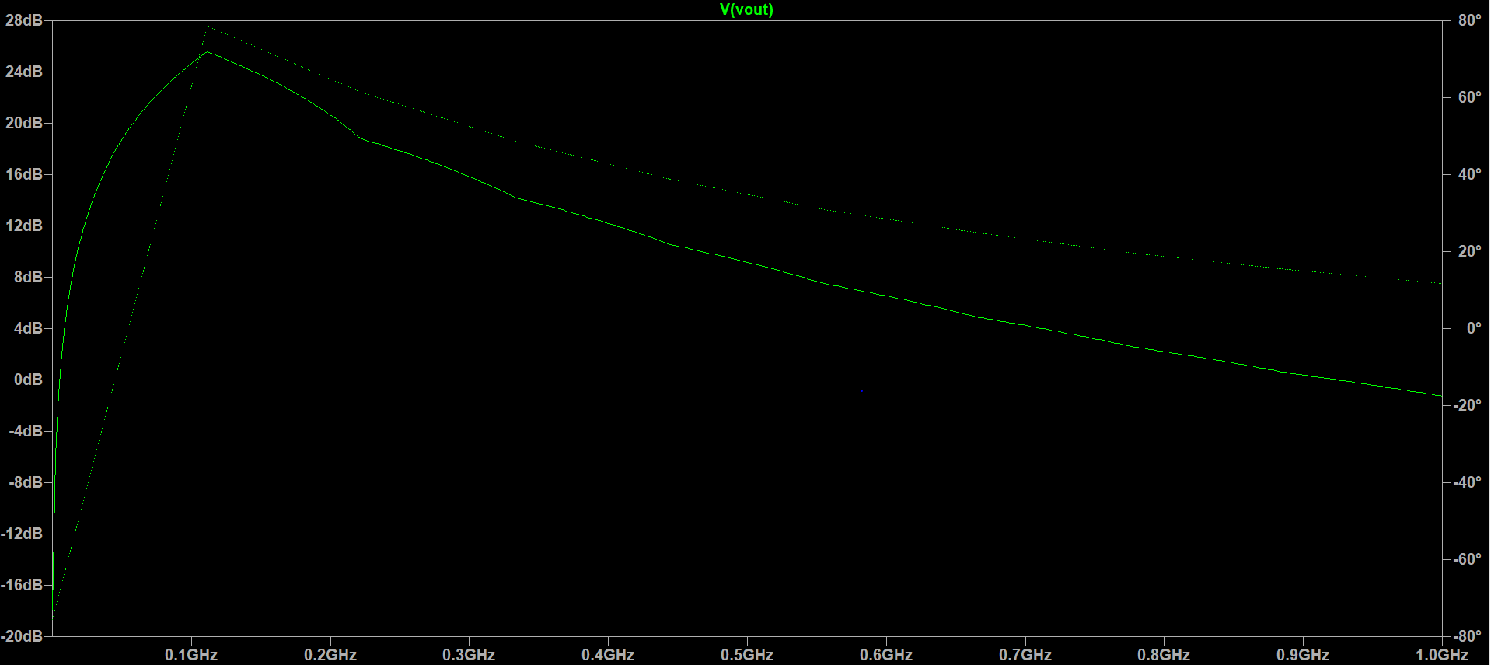

Circuit c) 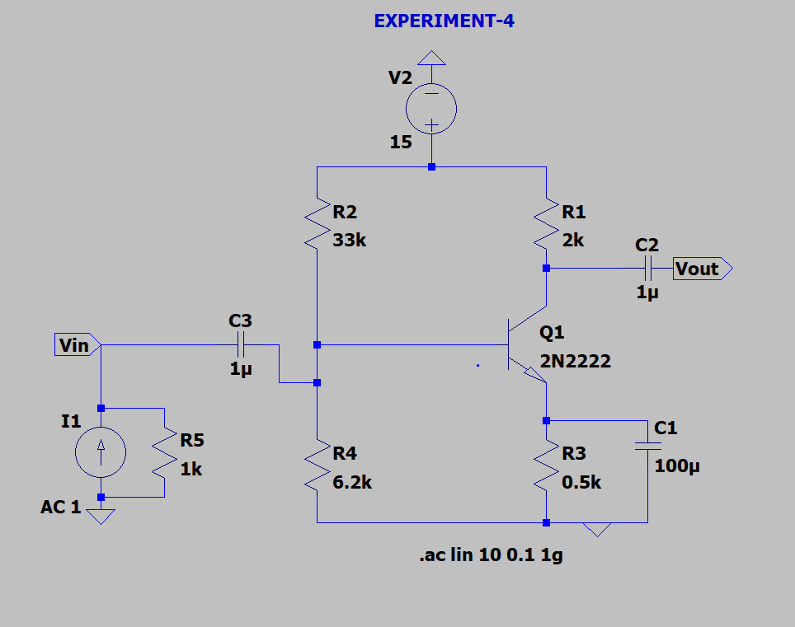

Output c) 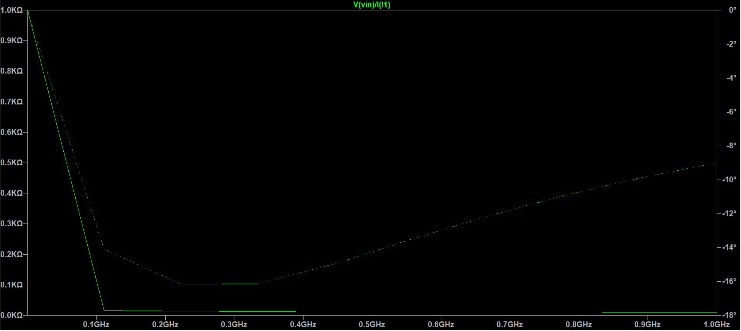

Circuit d) 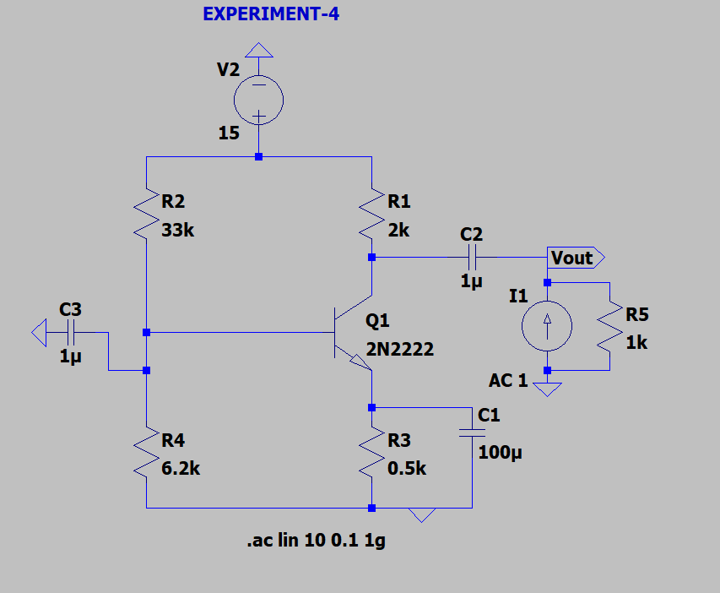

Output d) 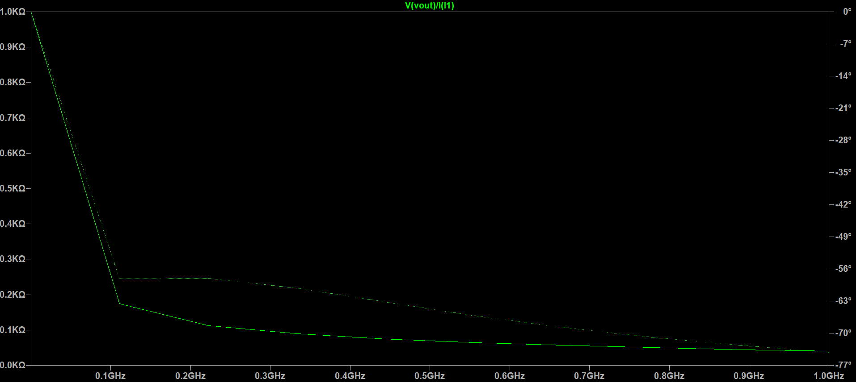

**By:Amogh Garg**

**2020UCO1688**

**COE(Section-3)**